Name:
Professor:
Course:
Date:
Microbiology lab final
- Helicobacter pylori
a). These bacteria are gram negative and appear as curved rods. They can be isolated using histopathologic examination. In this test, gastric biopsies are fixed in 10% buffered formalin for 24 hours and dipped in paraffin. The samples are cut in small pieces and de-paraffinized using alcohol. Haemotoxylin and eosin stain are used to help isolate the bacteria in a sample cell (Abu-Sbeih et al).
b). They are found in the stomach. They can also be found in food and water.
c). the medium required for growth should be rich in nutrients, serum, and a microaerobic environment.
d). selective growth conditions include microaerobic, anaerobic, and aerobic conditions.
e). they can be identified using histopathologic examination, rapid urease test, urease test, serology test, catalase test, oxidase test, and antibiotic susceptibility test (Abu-Sbeih et al). they are gram negative, curved rods, they are found in mucus.
f). It is a highly infectious bacteria. Its ability to induce disease is high considering that it causes more than 90% of ulcers (Hong et al).
g). H. pylori causes gastritis and stomach and duodenum ulcers (Illinois Dept. of Public Health).
h). the treatment for helicobacter pylori is antibiotics

Works cited
Abu-Sbeih, Ruba S, Hawari, Azmi D., Hassawi, Dhia S., Daghistani, Hala I. Isolation and Detection of Helicobacter pylori from patients suffering from peptic ulcers using biochemical tests and molecular techniques. American Journal of Biochemistry and Biotechnology 10.1, 2014: pp. 58-68. Doi: 10.3844/ajbbsp.2014.58.68.
Hong, Lu, Yoshio Yamaoka, David, Graham Y. Helicobater pylori virulence factors: facts and fantasies. Current Opinion on Gastroenterology 21.6 (2005): ppp653-659.
Illinois Dept. of Public Health. Helicobacter pylori. (2019). https://www.idph.state.il.us
- Salmonella
a). it can be isolated using different culture media, including blood agar, MacConkey, Bismuth sulfite agar, asalmonella-shigella agar, and Wilson Blair media among others (Nair).
b). they are found in the intestines of animals and humans. They can also be found in unpasteurized milk, raw meat, eggs, and poultry.
c). media required for recovery is enrichment broths, differential or selective agar, and blood agar (WHO).
d). growth conditions for salmonella are aerobic, anaerobic, and substituting both.
e). they are identified using polymerase chain reaction. They are non-spore forming and predominantly enterobacteria. They obtain their energy from reduction reactions and oxidation. They are rod-shaped and gram negative.
f). virulence factors of salmonella are encoded on the chromosome of an organism. They develop drug resistance and effect an enormous efflux of water and electrolytes into the intestines. They have a non-phagocytic cell invasion (Andino and Hanning).
g). it causes acute gastroenteritis and can affect the nervous system, joints, bloodstream, and bone.
h). it is treated by drinking plenty of fluids. Severe cases are treated using antibiotics (WHO).
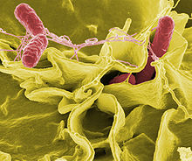
Works cited
Andino, A., and I. Hanning. “Salmonella enterica: survival, colonization, and virulence differences among serovars.” The Scientific World Journal 2015 (2015).
Nair, Amruta et al. “Isolation and identification of salmonella from diarrheagenic infants and young animals, sewage waste and fresh vegetables.” Veterinary world 8.5 92015): 669.
WHO. Salmonella (non-typhoidal). 2018. https://www.who.int/news-room/fact-sheets/detail/salmonella-(non-typhoidal)
- Vibrio cholera
a). they can be isolated using polymerase chain reaction or biochemical analyses (Huq et al).
b). they are found in food or water sources that are contaminated with feces from an infected person (Rodriguez and Chadi).
c). the medium used is Thiosulfate citrate bile salts sucrose sugar (TCBS) (Huq et al).
d). grows well under 37 ° C. grows in a wide range of pH. Anaerobic and aerobic environments.
e). identifying traits include gram negative, grows well under standard lab conditions, unable to survive under 4 ° C for long, able to grow under a wide range of PH and they are rod-shaped.
f). virulence factors are cholera toxin and toxin co-regulated pilus.
g). it causes cholera
h). Rehydration, IV fluids, and antibiotics

Works cited
Huq, Anwar, et al. “Detection, isolation, and identification of Vibrio cholera from the environment.” current protocols in microbiology 26.1 (2012): 6A-5.
Rodriguez, Jafet A. Ojeda, and Chadi I. Kahwaji. “Vibrio Cholerae.” StatPearls [internet]. StatPearls Publishing, 2018.
- Giardia lamblia
a). they are isolated by crossed and line immunoelectrophoresis (CIE) in agarose using rabbit antiserum (Faria et al).
b). they can be found in water, food, and soil that has been contaminated with feces from infected humans. They can also be found on surfaces.
c). media used manufactured TYI-S-33 and PEHPS
d). selective growth conditions are both aerobic and anaerobic. Rely on fermentation even in the presence of oxygen.
e). they have four pairs of flagella, they are binuclear, have a median body, are ventral disc-shaped, they are anaerobic (Merino et al).
f). virulence factors are cysteine proteases. The cysts are resistant and responsible for the transmission of the parasite.
g). causes giardiasis
h). it is treated using metronidazole, tinidazole, and nitazoxanide (Solayami et al)
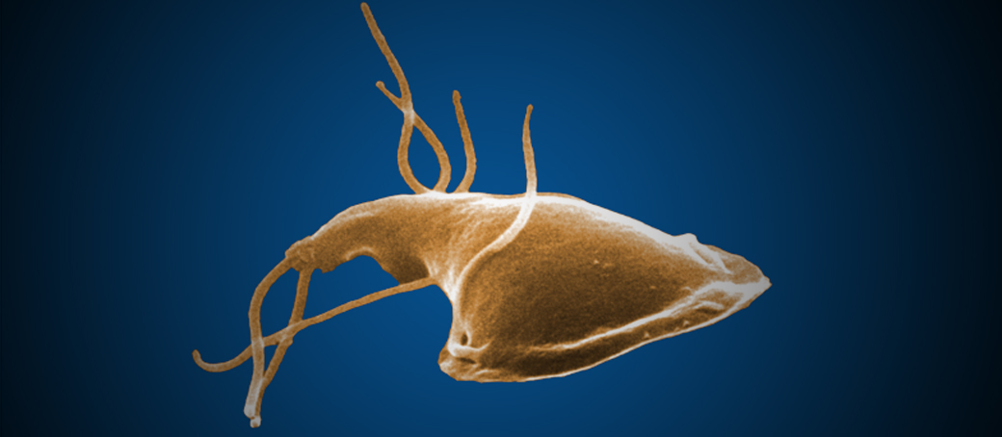
Works cited
Faria, Clarissa Perez, et al. “Molecular characterization of Giardia lamblia: first report of assemblage B in human isolates from Rio de Janeiro (Brazil).” PloS one 11.8 92016): e0160762.
Merino, Maria C., et al. “Identification of Giardia lamblia DHHC proteins and the role of protein S-palmitoylation in the encystation process.” PloS neglected tropical diseases. 8.7 (2014): e2997.
Solayami-Mohammadi S, Genkinger J. M. Loffredo C. A., AND Singer S. M. A meta-analysis of the effectiveness of albendazole compared with metronidazole as treatment for infections with Giardia duodenalis. Plos Negi Top Dis. 2010; 4.5: e682.
- Treponema pallidum
a). it is isolated by differential centrifugation (Mikalova et al)
b). predominant in tropical areas in India, Africa, S. America, and Pacific islands. Testicular cell membranes.
c). media used is a fresh sterile tissue in culture media
d). selective growth conditions are low concentrations of oxygen, anaerobic and acidic conditions (Edmondson et al)
e). identification traits are spirochaete bacterium, helically coiled, are gram negative, has three sub species, has a periplasmic flagella, has four polypeptides (Liu et al)
f). virulence factors are
g). causes syphilis, yaws, and bejel
h). it is treated using penicillin, antibiotics, and macrolides.
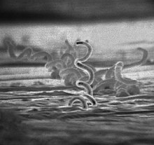
Works cited
Edmondson, Diane G., Bo Hu, and Steven J. Norris. “Long-term in vitro culture of the syphilis spirochete Treponema pallidum subsp. Pallidum.” MbIO 9.3 (2018): e01153-18.
Liu J, Howell J. K., Bradley S. D., Zheng Y., Zhou Z. H., and Norris S. J. “Cellular architecture of Treponema pallidum: novel flagellum, periplasmic cone, and cell envelope as revealed by cyro electron tomography.” Journal of Molecular Biology. 403.4: 546-61.
Mikalova, Lenka et al. “Human Treponema Pallidum 11q/j isolate belongs to subsp. Endemicum but contains two loci with a sequence in TP0548 and TP0488 similar to subsp. Pertenue and subsp. Pallidum respectivelt.” PLoS neglected tropical diseases 11.3 (2017): e0005434.
- Bacillus anthracis
a). they are isolated by suspending soil in sterile distilled water, which was filtered using cellulose nitrate. Deposits were then suspended in phosphate buffered saline and heated for fifteen minutes at 85 ° C (Chikerema et al).
b). commonly found in soil
c). polymyxin-lysozyme-EDTA-thallous acetate (PLET)
d). anaerobic bacterium that growth at standard lab temperatures, aerobic conditions, and ordinary nutrient medium.
e). gram positive, rod-shaped, has three species, can remain inactive for long, they form oval spores, white or cream colored.
f). non-contagious infectious diseases that affects a wide range of animals. Has three virulence factors, i.e., edema toxin, lethal toxin, and capsule (Fasanella).
g). causes anthrax
h). it is treated using antibiotics (Wilson)
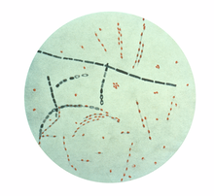
Works cited
Chikerema, S. M., et al. “Isolation of Bacillus anthracis from soil in selected high-risk areas of Zimbabwe.” Journal of applied microbiology 113.6 (2012): 1389-1395.
Fasanella, Antonio. “Bacillus anthracis, virulence factors, PCR, and interpretation of results.” Virulence 4.8 (2013): 659-660.
Wilson, Kenneth H. “Treatment of anthrax.”
- Trichomonas vaginalis
a). simultaneous isolation used. PCR. (Robertson et al)
b). commonly found in female lower genital tract and male urethra and prostate (Garber)
c). media used are Diamond’s medium and Kupferberg’s STS (Houso et al)
d). anaerobic flagellated parasite. Aerobic conditions.
e). transmitted through sexual intercourse, skin-to-skin conduct, exists in one morphological stage, larger than white blood cells, lacks cysts form
f). has high adherence factors, cysteine proteinases, microfilaments, microtubules, and bacterial adhesins.
g). causes trichomoniasis
h). it is treated with tinidazole and metronidazole.
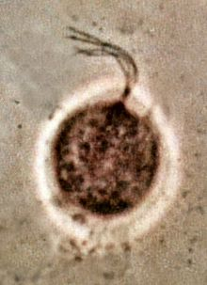
Works cited
Garber, Gary E. “The laboratory diagnosis of Trichomonas vaginalis.” Canadian Journal of Infectious Diseases and Medical Microbiology 16.1 (2005): 35-38.
Houso Yasmeen et al. “Detection of Trichomonas vaginalis in vaginal swab clinical samples from Palestinian women by culture.” ISRN microbiology 2011 (2011).
Robertson, D.H., Lumsden W.H., Fraser K.F., et al. Simultaneous isolation of Trichomonas vaginalis and collection of vaginal exudate. Sexually Transmitted Infections 1969; 45:42-43.
- Serratia marcescens
a). isolated by use of chitinase (Parani et al)
b). found in sterile places and subgingival biofilm of teeth.
c). media used is agar medium with yeast extract, caprylic acid, and thallous sulfate (Giri et al).
d). facultative anaerobic
e). gram negative, opportunistic pathogen, rod-shaped, motile, produces extracellular metalloproteinases,
f). virulence factor is hemolysin ShIA (Ishii et al).
g). causes urinary tract infections, wound infections, and catheter associated bacteremia.
h). it is treated with aminoglycoside and antipseudomonal beta-lactam.
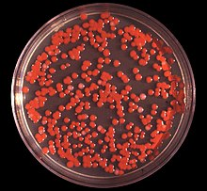
Works cited
Giri, Anuradha V., et al. “A novel medium for the enhanced cell growth and production of prodigiosin from Serratia marcescens isolated from soil.” BMC microbiology 4.1 (2004): 11.
Ishii, Kenichi, et al. “Identification of a serratia marcescenes virulence factor that promotes hemolymph bleeding in the silkworm, Bombx mori.” Journal of invertebrate pathology 117 (2014): 61-67.
Parani, K., G. P. Shetty, and B. K. Saha. “Isolation of Serratia marcescens SR1 as a source of chitinase having potentiality of using as a biocontrol agent. Indian Journal of microbiology 51.3 (2011): 247-250.
- Mycobacterium leprae
a). it is isolated using phenolic glycolipid antigen (Mohanty et al)
b). found in decaying organic matter (WHO)
c). media used is ICRC strains.
d). aerobic bacteria
e). rod-shaped, strongly acid fast, parallel sides and rounded ends, resembles tubercle bacillus
f). this bacterium has a unique cell wall that is hard to penetrate. Has a waxy exterior coating formed by production of mycolic acids (Wheat et al)
g). causes leprosy
h). treated using antibiotics like rifampin, clofazamine, azithromycin, and dapsone.
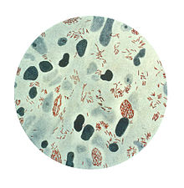
Works cited
Mohanty, Partha Sarathi, et al. “Viability of Mycobacterium leprae in environment and its role in leprosy dissemination.” Indian Journal of Dermatology, Venerology, and Leporology 82.1 (2016): 23.
Wheat, William H., et al. “Long-term survival and virulence of Mycobacterium leprae in amoebal cysts.” PLoS neglected tropical diseases 8.12 (2014): e3405.
WHO. Microbiology of M. leprae. 2019. https://www.int/lep/microbiology/en/
- Epstein Barr virus
a). it is isolated by use of soft agar and Burkitt’s lymphoma.
b). it is found everywhere in the world
c). Media used is Lymphoblastoid cell lines (Yap et al).
d). aerobic and anaerobic
e). has a double helix DNA, has a DNA surrounded by nucleocapsid, can infect both epithelial and B cells, has two major types type 1 and 2 (Martelius, et al)
f). virulence factors are ability to remain latent for years (Thorley-Lawson et al).
g). causes infectious mononucleosis
h). it is treated using corticosteroids and antiviral medications
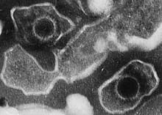
Works cited
Martelius, Timi, et al. “Clinical characteristics of patients with Epstein Barr virus in cerebrospinal fluid.” BMC infectious diseases 11.1 (2011): 281.
Thorley-Lawson, David et al. “The pathogenesis of Epstein-Barr Virus persistent infection.” Current opinion in virology 3.3 (2013): 227-232.
Yap, Hooi-Yeen, et al. “Epstein-Barr virus (EBV) Immortalized Lymphoblastoid Cell Lines (LCLs) Express High Level of CD23 but low CD27 to support Their Growth.” Advances in virology 2019 (2019).

